**Why subject is important**

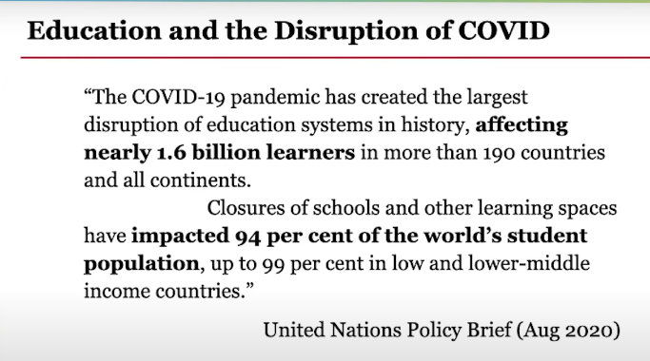We know that for the last two years the whole world is suffering because of COVID 19. Many of the human life is vanished from here in a sudden because of this pandemic, still many are fighting with their lives. Each sector of the world is affected very badly due to this dangerous condition even our economic sector, health sector, education sector etc. The COVID pandemic has created the largest disturbance in education systems in history. Affecting nearly 1.6 billion learners, according to the United nation. The closure of schools and other learning spaces have impacted 94% of the world's student population, up to 99% of those students who are in lower and middle-income countries.

**Challenges and solutions**

With the onset of COVID, one thing became crystal clear. Our education system does more than just focus on academics. Schools are more than just physical buildings that provide academic content. They provide regular access to food and healthcare. And educators do more than just stimulate minds, they provide critical social-emotional support and the safety of adult supervision. Community-based organizations also are important and our supports that we give to students and essential in supporting and protecting them beyond the school day. So, we realized just how essential schools, teachers, our system is, to making all of our lives work. And now nearly a year later, education has suffered rapid change. The COVID 19 crisis has had an unpredicted impact on education. The education of more than 90% students globally was disrupted by institutional closures. When the COVID 19 pandemic struck, the education sector was clearly not and had to look for immediate solutions. E-learning was the preferred option but how many students have access to electricity, computers and connectivity only half the world's population have internet access with a wide variation, ranging from nearly 95% access in a rich country like Brunei to less than 15% in some of the others. 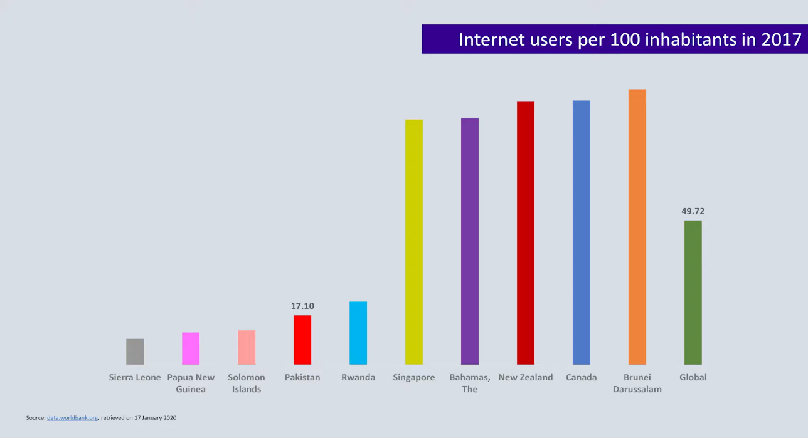 While the status of mobile subscriptions is more encouraging with over 100% in most countries. Access is not universal, so we have to use, kind of technologies to ensure that we reach the last person in the queue.

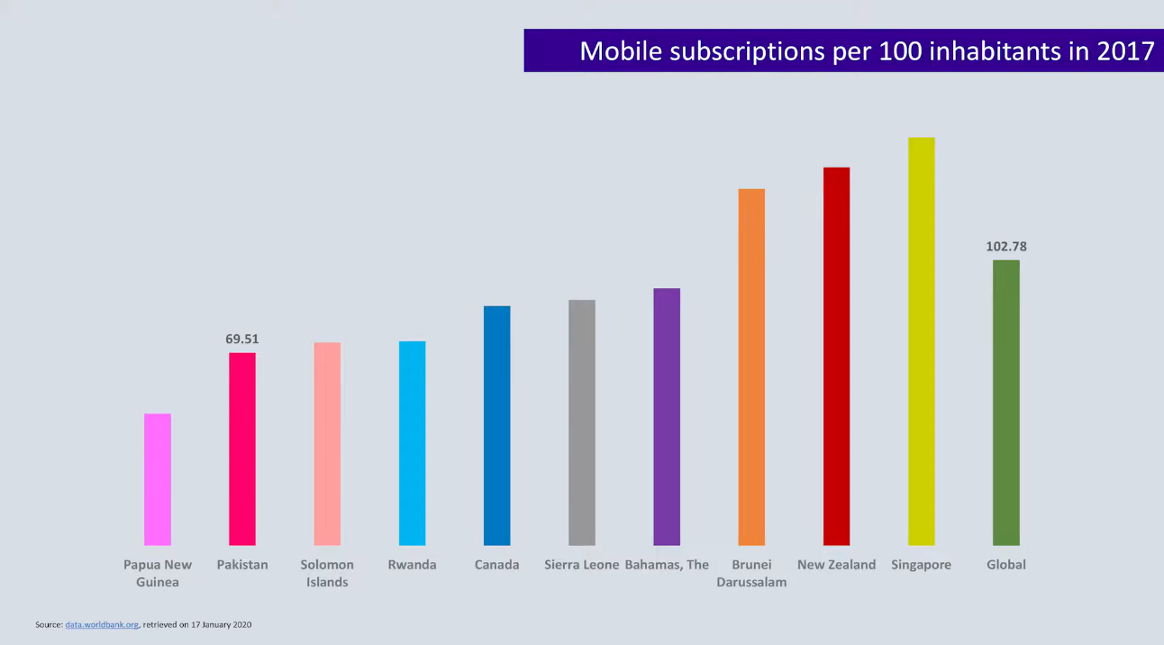

Challenges for e-learning from four perspectives

1. Social issues: - growing inequality that institutions need to combat.
2. Pedagogical challenge: - teachers had to make the sudden transition to online mode.
3. The challenge of harnessing technology for teaching and learning.
4. The psychological impact and the anxieties resulting from the uncertainty about the future

While students with resources have continued to learn. It is the poorest children who have been hardest hit. UNESCO estimates that about 11 million girls may never return to school due to this crisis. In pre-covid 19 days children in a remote region in Bangladesh studied in these boat schools which picked them up from the villages and dropped them home after classes were over.

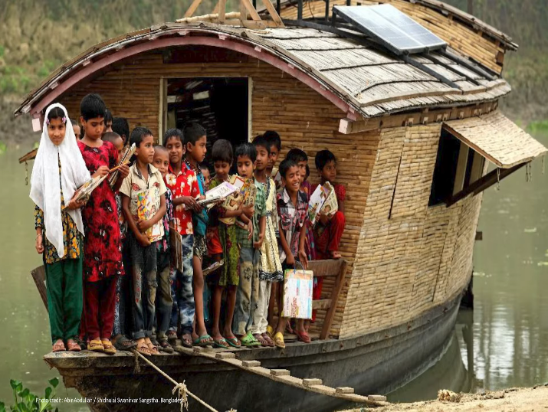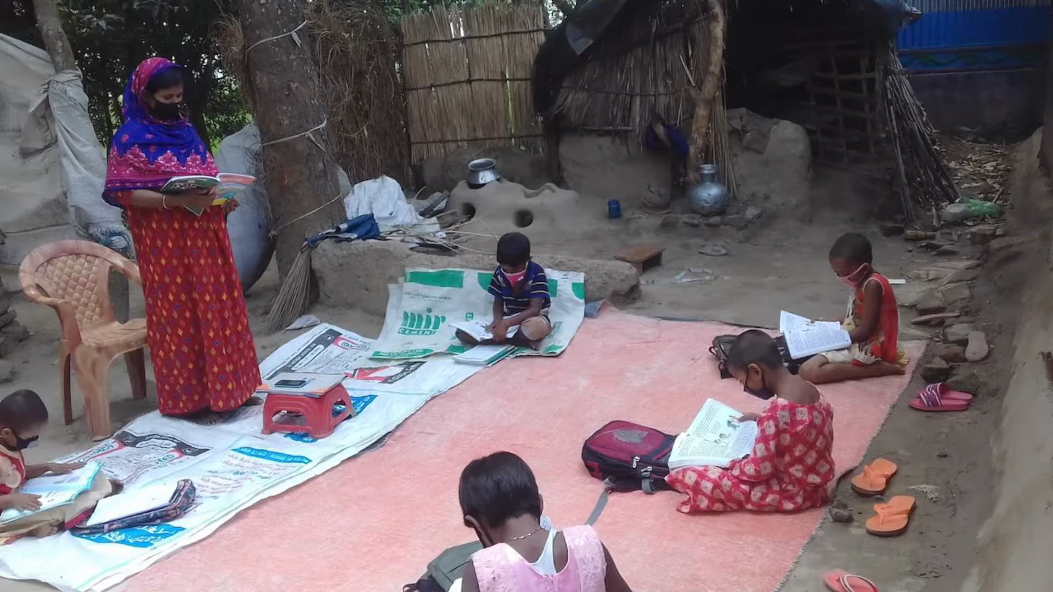

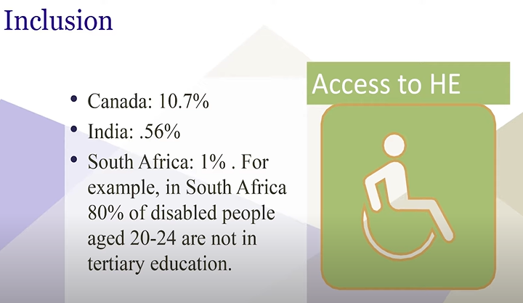As this was no longer possible in the pandemic the only way to reach them was to bring the teachers to the communities and maintain social distance. The only technology available to those children is print materials.

Another constituency that is in danger of being further marginalized during this crisis are persons with disabilities even in normal circumstances the participation of persons with disabilities in higher education has been very low especially in developing countries such as in India and South Africa.

world has been forced to use technology we will need to ensure that the technologies are available accessible and affordable a recent survey of Stanford university students by conducted by Tony Bates found that 16 percent of undergraduates did not have access to the internet for half the time and 60 percent undergraduates from low-income families did not have a private place to study now if this is the situation in a resource-rich university like Stanford how do we reach students in developing countries

Parents are suffering from job losses and students are dealing with school closures and isolation the need for empathy and well-being has been highlighted as never before with more persons using technology there are the challenges of cyber security data privacy and the safety of network devices that we need to look into. In such conditions some private schools hike school fees that creates more traceful situation for parents.

**Methodology**

* Institutions have realized the value of frequent communications with their students for example the national institute of open schooling in India as established call centres to support learners. Similarly, in Jamaica they have provided free sim cards to parents so that they can access the help lines that the ministry has set up for them.
* For institutions the top priority must be to build the capacity of both staff and students in e-learning research shows that blended learning works best in developing countries and blended learning refers to a combination of e-learning and face-to-face provision it's up to the institutions to decide what percentage of each component they need to use depending on the availability of resources and you can see from this chart that there are various options.
* Persons with disabilities prefer distance learning as it is more convenient more flexible affordable and provides a degree of anonymity. Allama Iqbal open university has special programs for persons with disabilities and can provide valuable lessons for other institutions.
* Researchers in Canada analysed three types of interactions student-content, student-student and student-teacher to identify which had the best impact on learning outcomes and they found that the student-content interaction was the most effective. Teachers had to move overnight from classroom lectures to online mode. Students had to learn remotely without any support and parents were expected to help students with their lessons so would access to quality content.

Conclusion

From the experience of this pandemic one thing has certainly become clear that we need to find innovative solutions appropriate to each different context so that we do not leave anyone behind.